 **Notation Definition**

**K:** number of Gaussian Contours

**m:** M-step is executed every m samples(∑,μ,π of GMM are update

updated when every m samples added)

**N:** number of samples in the off-line loop

**Amplify Factor:** factor of amplify the ∑ of initial GMM(From

the Figure(4)&(5), the initial method really works)

**Comparison Summary Table**

|  |  |  |  |
| --- | --- | --- | --- |
| K\m | 100 | 1000 | 10000 |
| 100 |  | Few skinny Gauss | Normal Gauss |
| 1000 | overfitting | Skinny Gauss(little overfitting) |  |

(1)Original Image





(2)Simulated Image 1 (3)Simulated Image 2

K = 1000, m = 1000, N = 1000 K = 1000, m = 100, N = 1000



(4)Simulated Image3 (5)Simulated Image4 (6)Simulated Image5

K = 100,m =1000,N = 1000 K = 100, m = 1000,N = 1000 K = 100, m =10000, N = 10000

Amplify factor: 10



**Comparison Summary Table:**

|  |  |  |
| --- | --- | --- |
| Converge Condition\Iteration Times | 150000 | 200000 |
| 10e-03 |  | More accurate  Similar Gauss with 10e-05 |
| 10e-05 | Few skinny Gauss |  |

(1)Original Image



(7a)Simulated Image 7 (7b)GMM of Image7

K = 1000, m = 10000, N = 10000 Offline Converge condition: <0.001|| i>5*N

 End Iteration Times: 150000 Online Converge condition:<0.00001|| i>150000

(8a)Simulated Image8 (8b)GMM of Image8

K = 1000, N = 10000, m = 10000 Offline condition <0.001 || I > 10*N

End iteration times = 180000 Online condition < 0.001 || I > 200000

End condition: 5.8117e-04

Stratified Sample Image: (Need to fix ::Correct Image Come soon)

k = 100 m = 1000 n = 1000

K = 100 m = 10000 N = 10000

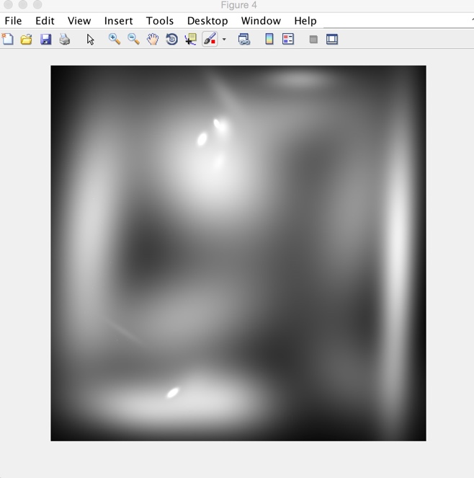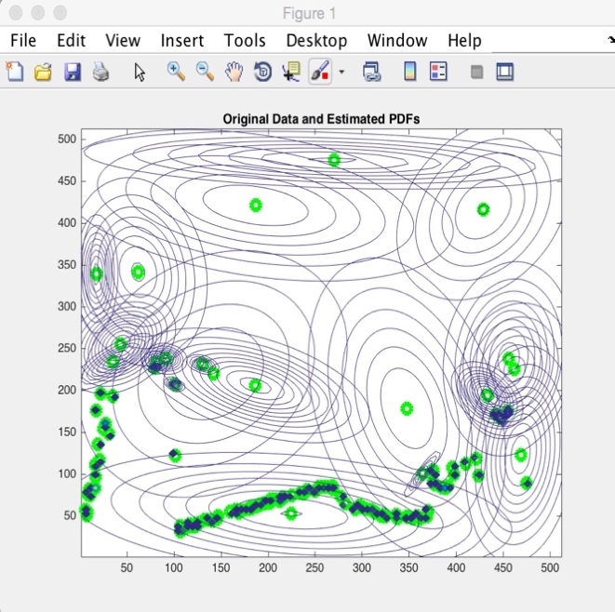



1. Original Image



(3a)k=100 m = 1000 random sample



(9a)k=100 m = 1000 Stratified sample